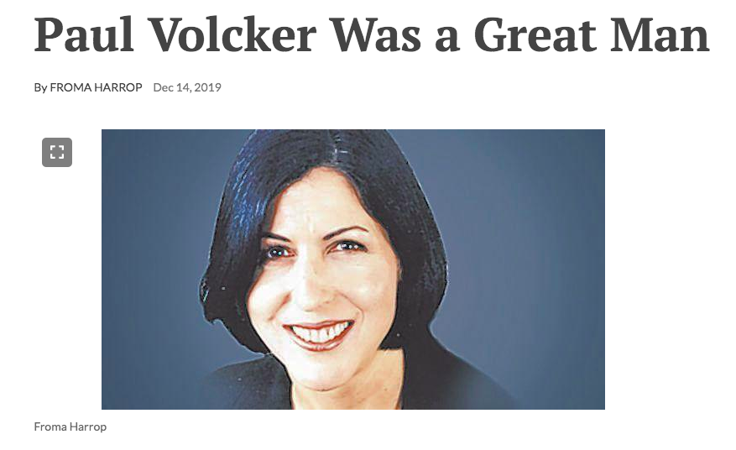
https://www.godanriver.com/opinion/columnists/harrop_froma/paul-volcker-was-a-great-man/article_85b1049b-9ed3-5668-b5c4-7cfb32b2f37c.html
Paul Volcker administered the tough medicine when the American economy badly needed it. It was 1980, and the inflation rate had passed 14 percent. OPEC, a cartel of foreign oil producers, had launched an oil embargo against the United States a few years before, causing prices to soar. Older Americans remember long lines of cars snaking to gas pumps. The country felt in crisis.
President Jimmy Carter appointed Volcker chairman of the Federal Reserve Board to fix inflation. Volcker knew he had to raise interest rates to beat it down. He did and succeeded, but the cost was a sharp economic downturn. Workers lost jobs, and many regarded Volcker as the villain.
Ronald Reagan defeated Carter in 1980. As president, he took credit for a growing economy, thanks in good part to Volcker’s having conquered inflation and falling oil prices. That occurred as consumers responded to the oil shock by reining in their use of — and, therefore, demand for — oil.
Reagan wanted to loosen the rules governing Wall Street. Volcker believed in them, so Reagan replaced Volcker as Fed chairman with Alan Greenspan. The relaxation of regulations led to the savings and loan crisis, which forced a massive government bailout of failing institutions. Reagan’s tax cuts and defense spending gave the economy a temporary boost. But by the time he left office, the national debt had doubled.
Under President Bill Clinton, taxes were raised and budget deficits turned to surpluses. There was even talk of eliminating the national debt altogether.
Then George W. Bush became president. Again, Wall Street was turned loose; taxes were cut; and federal spending took off. The Bush presidency ended with a financial meltdown leading to the worst recession since the Great Depression.
Entering office with an economy in ruins, President Barack Obama named Volcker chair of his Economic Recovery Advisory Board. There Volcker pushed for the Dodd-Frank regulatory overhaul. That included the Volcker Rule, which curtailed the banks’ ability to take risks with the depositors’ money.
President Trump is following his Republican predecessors’ path of slashing taxes, accelerating spending and pushing for financial deregulation. Despite a strong economy — for the time being, anyway — deficits are skyrocketing.
In an interview a year ago with Barron’s, Volcker explained why the U.S. debt can’t continue its explosive growth. “Someday confidence is lost,” he said. “The longer the imbalance lasts, the more difficult it is to correct.” He said that deficits can be good for business, enabling them to invest abroad and import more freely. “But eventually it breaks down,” hurting small manufacturers.
Volcker said he was OK with tariffs that were carefully applied. But in an interview held in February, he criticized Trump’s approach to China. “We are all threats and demands,” Volcker told hedge funder Ray Dalio, whereas he believes China seems to want “a harmonious relationship over time.”
Volcker’s biggest concerns of late have centered on Americans’ loss of trust in government. He laments the falloff in respect for public institutions among the rich, the poor and the middle class alike. “You can’t survive if people don’t trust their government to do the right thing most of the time,” he told Barron’s.
In his memoir, “Keeping at It,” released late last year, Volcker wrote, “Too many of the best in the assailed bureaucracy ... have left too soon, doubting that their voices could be heard or that their goals could be achieved.”
Volcker helped found The Volcker Alliance, a nonpartisan group dedicated to improving the efficiency and accountability of government at all levels.
Volcker died this week at the age of 92. He was a great man and a great American.
Harrop is a syndicated columnist. Email her at fharrop@gmail.com or follow her on Twitter @FromaHarrop.

